Hands on 2:
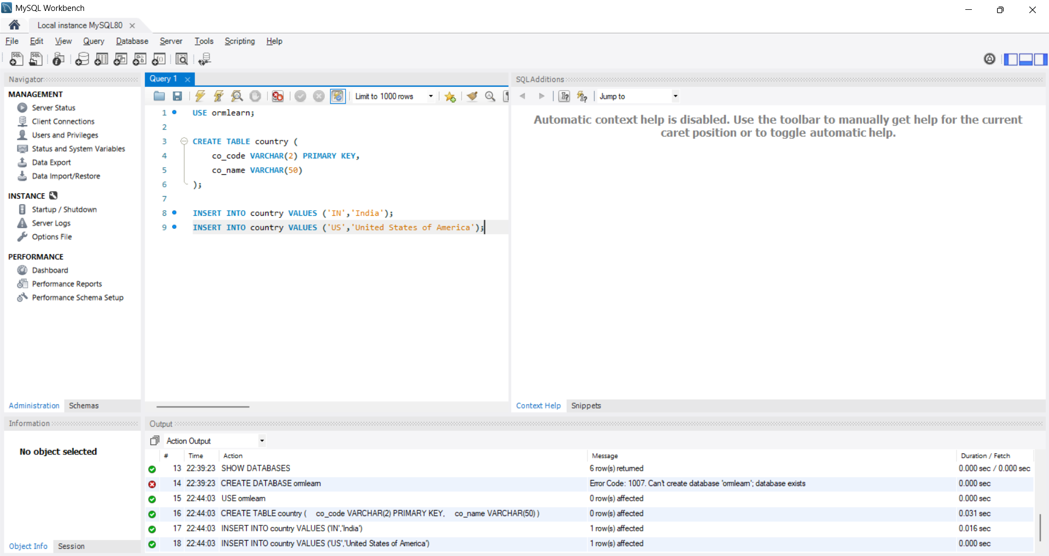
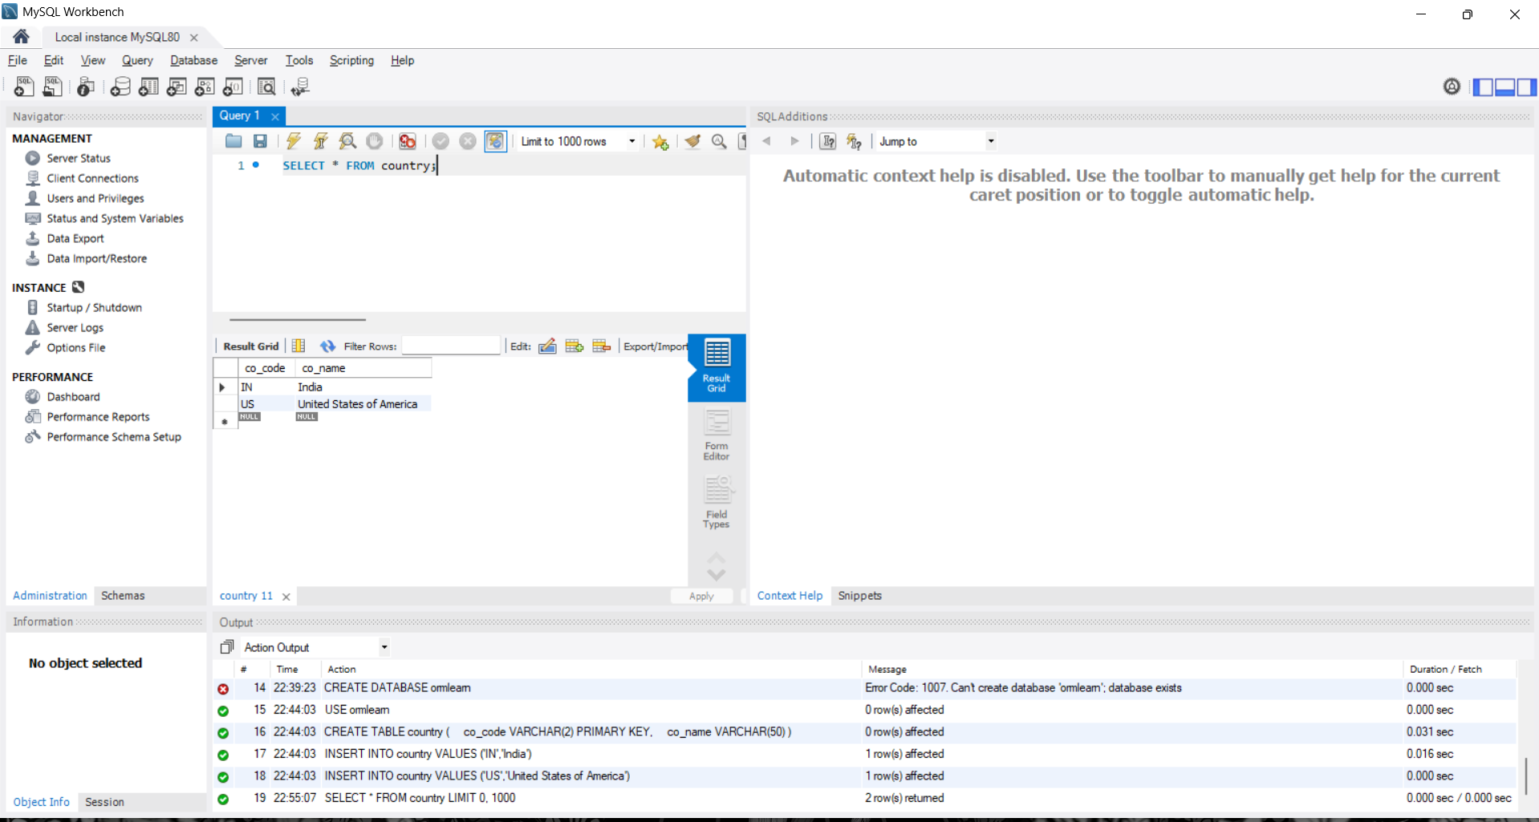
application.properties
logging.level.org.springframework=info
logging.level.com.cognizant=debug
logging.level.org.hibernate.SQL=trace
logging.level.org.hibernate.orm.jdbc.bind=trace
logging.pattern.console=%d{dd-MM-yy} %d{HH:mm:ss.SSS} %-20.20thread %5p %-25.25logger{25} %25M %4L %m%n
spring.datasource.driver-class-name=com.mysql.cj.jdbc.Driver
spring.datasource.url=jdbc:mysql://localhost:3306/ormlearn
spring.datasource.username=root
spring.datasource.password=Smayan@020804
spring.jpa.hibernate.ddl-auto=validate
spring.jpa.properties.hibernate.dialect=org.hibernate.dialect.MySQLDialect

schema.sql
USE ormlearn;

CREATE TABLE country (
co_code VARCHAR(2) PRIMARY KEY,
co_name VARCHAR(50)
);

INSERT INTO country VALUES ('IN','India');
INSERT INTO country VALUES ('US','United States of America');

Country.java
package com.cognizant.orm_learn.model;
import jakarta.persistence.Column;
import jakarta.persistence.Entity;
import jakarta.persistence.Id;
import jakarta.persistence.Table;
@Entity
@Table(name = "country")
public class Country {
@Id
@Column(name = "co_code")
private String code;
@Column(name = "co_name")
private String name;
public Country() {
}
public String getCode() {
return code;
}
public void setCode(String code) {
this.code = code;
}
public String getName() {
return name;
}
public void setName(String name) {
this.name = name;
}
@Override
public String toString() {
return "Country{" +
"code='" + code + '\'' +
", name='" + name + '\'' +
'}';
}
}
CountryRepository.java
package com.cognizant.orm_learn.repository;
import com.cognizant.orm_learn.model.Country;
import org.springframework.data.jpa.repository.JpaRepository;
import org.springframework.stereotype.Repository;
@Repository
public interface CountryRepository extends JpaRepository<Country, String> {
}
CountryService.java
package com.cognizant.orm_learn.service;
import com.cognizant.orm_learn.model.Country;
import com.cognizant.orm_learn.repository.CountryRepository;
import org.springframework.beans.factory.annotation.Autowired;
import org.springframework.stereotype.Service;
import org.springframework.transaction.annotation.Transactional;
import java.util.List;
@Service
public class CountryService {
@Autowired
private CountryRepository countryRepository;
@Transactional(readOnly = true)
public List<Country> getAllCountries() {
return countryRepository.findAll();
}
}

OrmLearnApplication.java
package com.cognizant.orm_learn;
import com.cognizant.orm_learn.service.CountryService;
import org.springframework.boot.SpringApplication;
import org.springframework.boot.autoconfigure.SpringBootApplication;
import org.springframework.context.ApplicationContext;
@SpringBootApplication
public class OrmLearnApplication {
public static void main(String[] args) {
ApplicationContext context =
SpringApplication.run(OrmLearnApplication.class, args);
CountryService service = context.getBean(CountryService.class);
System.out.println(service.getAllCountries());
}
}

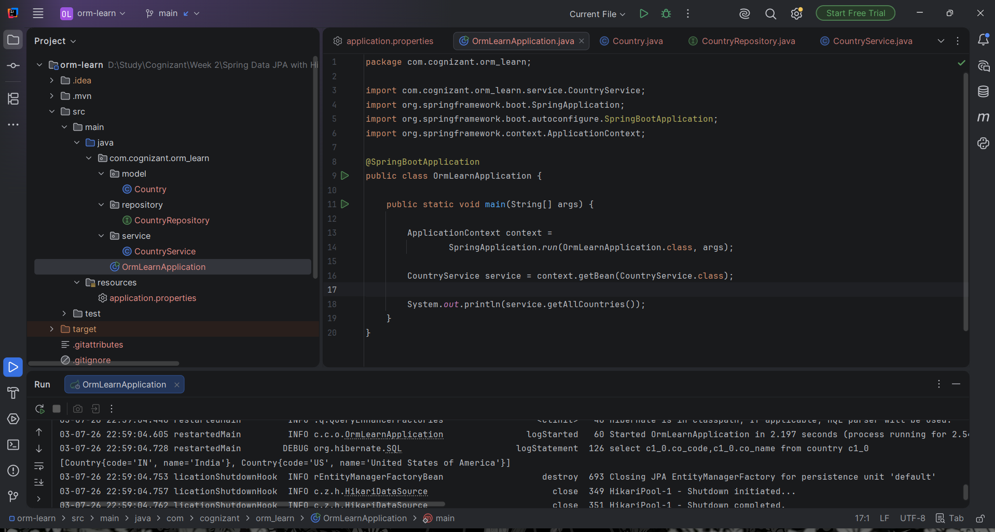

Hands on 5:
OrmLearnApplication.java
package com.cognizant.orm_learn;
import com.cognizant.orm_learn.model.Country;
import com.cognizant.orm_learn.service.CountryService;
import org.springframework.boot.SpringApplication;
import org.springframework.boot.autoconfigure.SpringBootApplication;
import org.springframework.context.ApplicationContext;
@SpringBootApplication
public class OrmLearnApplication {
public static void main(String[] args) {
ApplicationContext context =
SpringApplication.run(OrmLearnApplication.class, args);
CountryService service = context.getBean(CountryService.class);
try {
Country country = service.findCountryByCode("IN");
System.out.println(country);
} catch (Exception e) {
e.printStackTrace();
}
}
}
CountryService.java
package com.cognizant.orm_learn.service;
import com.cognizant.orm_learn.exception.CountryNotFoundException;
import com.cognizant.orm_learn.model.Country;
import com.cognizant.orm_learn.repository.CountryRepository;
import org.springframework.beans.factory.annotation.Autowired;
import org.springframework.stereotype.Service;
import org.springframework.transaction.annotation.Transactional;
import java.util.List;
import java.util.Optional;
@Service
public class CountryService {
@Autowired
private CountryRepository countryRepository;
@Transactional(readOnly = true)
public List<Country> getAllCountries() {
return countryRepository.findAll();
}
@Transactional(readOnly = true)
public Country findCountryByCode(String countryCode)
throws CountryNotFoundException {
Optional<Country> result = countryRepository.findById(countryCode);
if (result.isEmpty()) {
throw new CountryNotFoundException("Country not found: " + countryCode);
}
return result.get();
}
}
CountryNotFoundException.java
package com.cognizant.orm_learn.exception;
public class CountryNotFoundException extends Exception {
public CountryNotFoundException(String message) {
super(message);
}
}
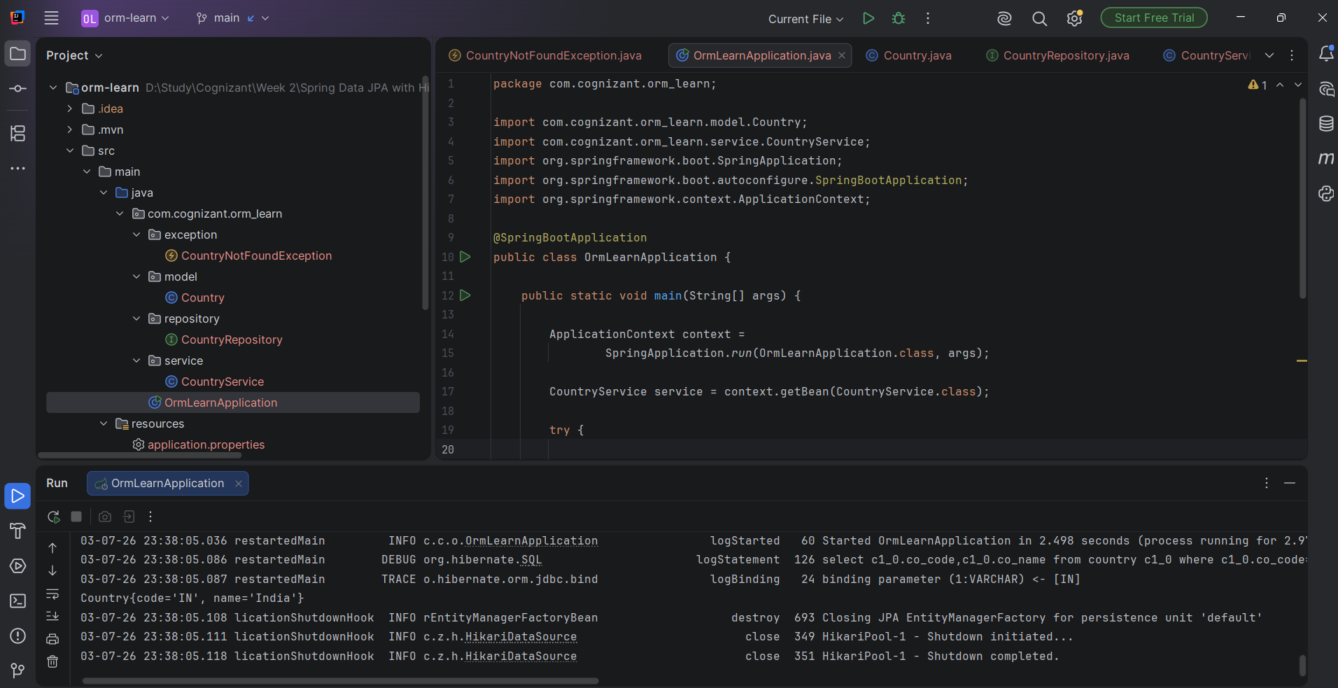

Hands On 7:
OrmLearnApplication.java
package com.cognizant.orm_learn;
import com.cognizant.orm_learn.model.Country;
import com.cognizant.orm_learn.service.CountryService;
import org.springframework.boot.SpringApplication;
import org.springframework.boot.autoconfigure.SpringBootApplication;
import org.springframework.context.ApplicationContext;
@SpringBootApplication
public class OrmLearnApplication {
public static void main(String[] args) {
ApplicationContext context =
SpringApplication.run(OrmLearnApplication.class, args);
CountryService service = context.getBean(CountryService.class);
Country country = new Country();
country.setCode("NP");
country.setName("Nepal");
service.addCountry(country);
try {
System.out.println(service.findCountryByCode("NP"));
} catch (Exception e) {
e.printStackTrace();
}
}
}
CountryService.java
package com.cognizant.orm_learn.service;
import com.cognizant.orm_learn.exception.CountryNotFoundException;
import com.cognizant.orm_learn.model.Country;
import com.cognizant.orm_learn.repository.CountryRepository;
import org.springframework.beans.factory.annotation.Autowired;
import org.springframework.stereotype.Service;
import org.springframework.transaction.annotation.Transactional;
import java.util.List;
import java.util.Optional;
@Service
public class CountryService {
@Autowired
private CountryRepository countryRepository;
@Transactional(readOnly = true)
public List<Country> getAllCountries() {
return countryRepository.findAll();
}
@Transactional(readOnly = true)
public Country findCountryByCode(String countryCode)
throws CountryNotFoundException {
Optional<Country> result = countryRepository.findById(countryCode);
if (result.isEmpty()) {
throw new CountryNotFoundException("Country not found: " + countryCode);
}
return result.get();
}
@Transactional
public void addCountry(Country country) {
countryRepository.save(country);
}
}
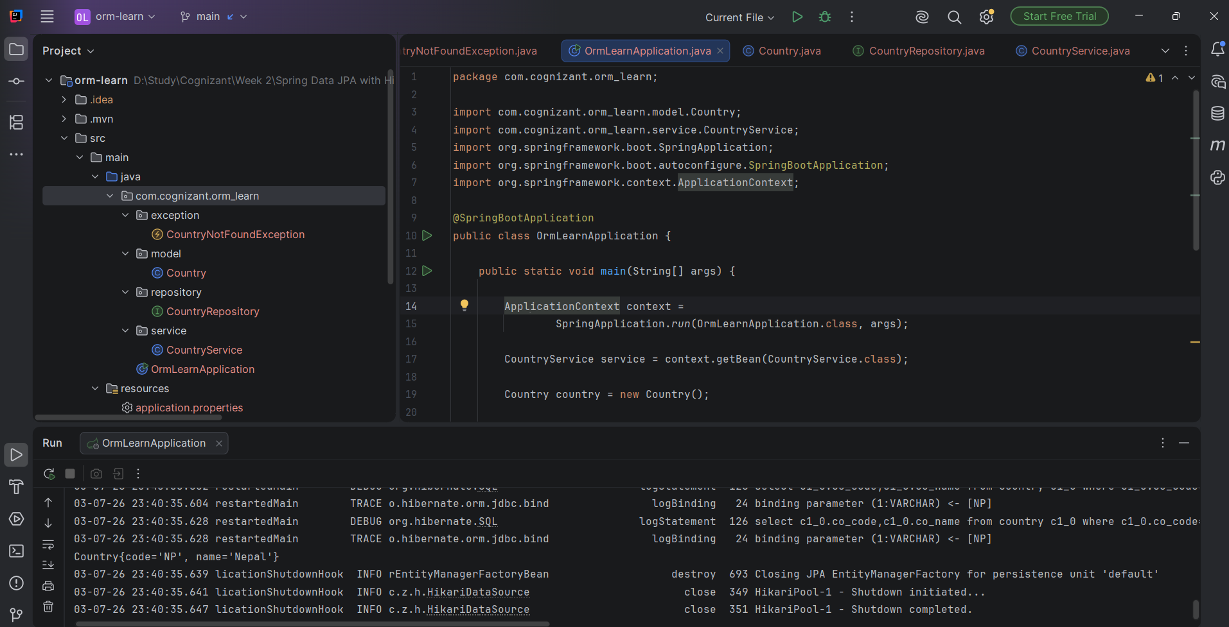
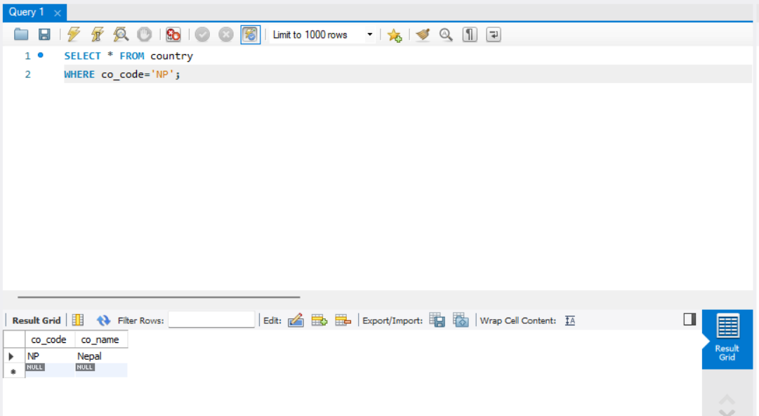

Hands On 8:
OrmLearnApplication.java
package com.cognizant.orm_learn;
import com.cognizant.orm_learn.model.Country;
import com.cognizant.orm_learn.service.CountryService;
import org.springframework.boot.SpringApplication;
import org.springframework.boot.autoconfigure.SpringBootApplication;
import org.springframework.context.ApplicationContext;
@SpringBootApplication
public class OrmLearnApplication {
public static void main(String[] args) {
ApplicationContext context =
SpringApplication.run(OrmLearnApplication.class, args);
CountryService service = context.getBean(CountryService.class);
try {
service.updateCountry("IN", "Updated Sample Country");
System.out.println(service.findCountryByCode("IN"));
} catch (Exception e) {
e.printStackTrace();
}
}
}
CountryService.java
package com.cognizant.orm_learn.service;
import com.cognizant.orm_learn.exception.CountryNotFoundException;
import com.cognizant.orm_learn.model.Country;
import com.cognizant.orm_learn.repository.CountryRepository;
import org.springframework.beans.factory.annotation.Autowired;
import org.springframework.stereotype.Service;
import org.springframework.transaction.annotation.Transactional;
import java.util.List;
import java.util.Optional;
@Service
public class CountryService {
@Autowired
private CountryRepository countryRepository;
@Transactional(readOnly = true)
public List<Country> getAllCountries() {
return countryRepository.findAll();
}
@Transactional(readOnly = true)
public Country findCountryByCode(String countryCode)
throws CountryNotFoundException {
Optional<Country> result = countryRepository.findById(countryCode);
if (result.isEmpty()) {
throw new CountryNotFoundException("Country not found: " + countryCode);
}
return result.get();
}
@Transactional
public void addCountry(Country country) {
countryRepository.save(country);
}
@Transactional
public void updateCountry(String code, String name)
throws CountryNotFoundException {
Optional<Country> result = countryRepository.findById(code);
if (result.isEmpty()) {
throw new CountryNotFoundException("Country not found: " + code);
}
Country country = result.get();
country.setName(name);
countryRepository.save(country);
}
}
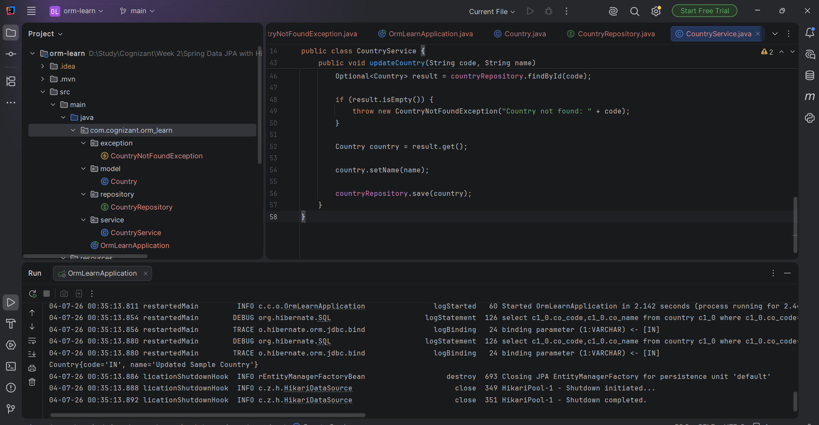
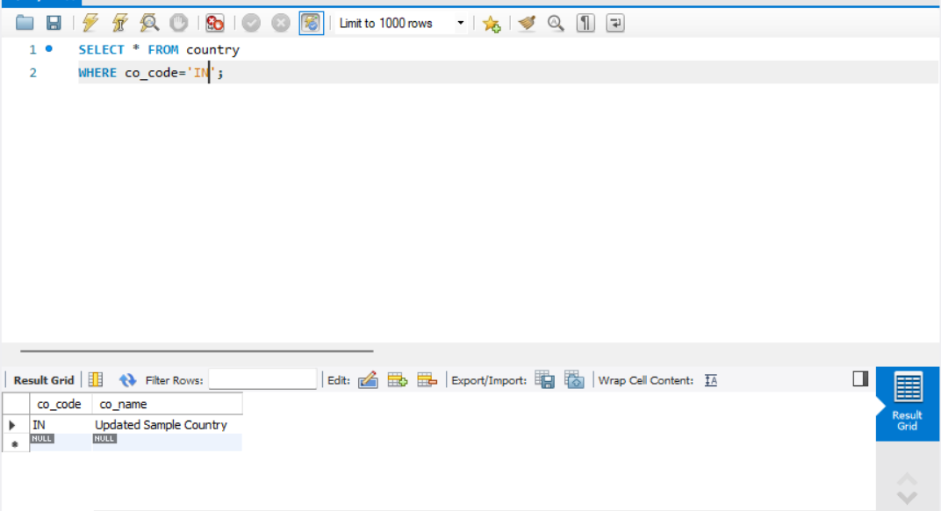
Hands On 9:
OrmLearnApplication.java
package com.cognizant.orm_learn;
import com.cognizant.orm_learn.model.Country;
import com.cognizant.orm_learn.service.CountryService;
import org.springframework.boot.SpringApplication;
import org.springframework.boot.autoconfigure.SpringBootApplication;
import org.springframework.context.ApplicationContext;
@SpringBootApplication
public class OrmLearnApplication {
public static void main(String[] args) {
ApplicationContext context =
SpringApplication.run(OrmLearnApplication.class, args);
CountryService service = context.getBean(CountryService.class);
service.deleteCountry("IN");
System.out.println("Country deleted successfully.");
}
}
CountryService.java
package com.cognizant.orm_learn.service;
import com.cognizant.orm_learn.exception.CountryNotFoundException;
import com.cognizant.orm_learn.model.Country;
import com.cognizant.orm_learn.repository.CountryRepository;
import org.springframework.beans.factory.annotation.Autowired;
import org.springframework.stereotype.Service;
import org.springframework.transaction.annotation.Transactional;
import java.util.List;
import java.util.Optional;
@Service
public class CountryService {
@Autowired
private CountryRepository countryRepository;
@Transactional(readOnly = true)
public List<Country> getAllCountries() {
return countryRepository.findAll();
}
@Transactional(readOnly = true)
public Country findCountryByCode(String countryCode)
throws CountryNotFoundException {
Optional<Country> result = countryRepository.findById(countryCode);
if (result.isEmpty()) {
throw new CountryNotFoundException("Country not found: " + countryCode);
}
return result.get();
}
@Transactional
public void addCountry(Country country) {
countryRepository.save(country);
}
@Transactional
public void updateCountry(String code, String name)
throws CountryNotFoundException {
Optional<Country> result = countryRepository.findById(code);
if (result.isEmpty()) {
throw new CountryNotFoundException("Country not found: " + code);
}
Country country = result.get();
country.setName(name);
countryRepository.save(country);
}
@Transactional
public void deleteCountry(String code) {
countryRepository.deleteById(code);
}
}
